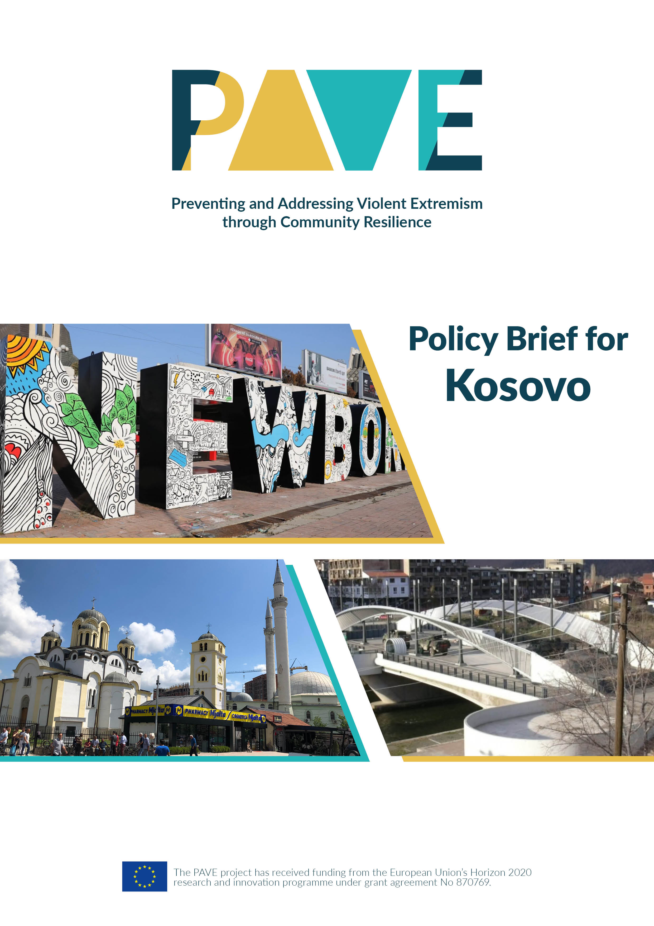

 **Introduction to the PAVE project**

The PAVE research project (2020-23) collects evidence-based knowledge on trends in radicalisation and violent extremism in the Middle East and North Africa (MENA) and Western Balkans. Its aim is to strengthen the capacity of policy-makers and community leaders for the development of an effective prevention strategy between the European Union and its neighbourhood. In addition to research reports and policy briefs, innovative training tools for stakeholders are developed based on the project’s findings.

The PAVE consortium consists of 13 partner organisations based in 12 countries, and places particular emphasis on locally-led research with deep contextual familiarity and stakeholder access within the regions under study. It brings together partners with unique and complementary strengths as well as shared areas of interest, in order to foster joint learning and development. In all countries, community leaders such as local state representatives, religious leaders, educators, youth organisations and women’s organisations were consulted to validate first the research plans and later the research findings.

Empirical data was gathered in seven case study countries through a variety of qualitative, quantitative and mixed-method approaches and compared across selected communities (e.g. municipalities) which are unevenly affected by violent extremism. Factors of vulnerability and resilience were identified at the meso level of community dynamics and actors, based on three thematic clusters: the interface between religious, political and ethnic/sectarian extremisms; the interaction between religious and public institutions; and the interplay between online and offline narratives on (de)radicalisation.

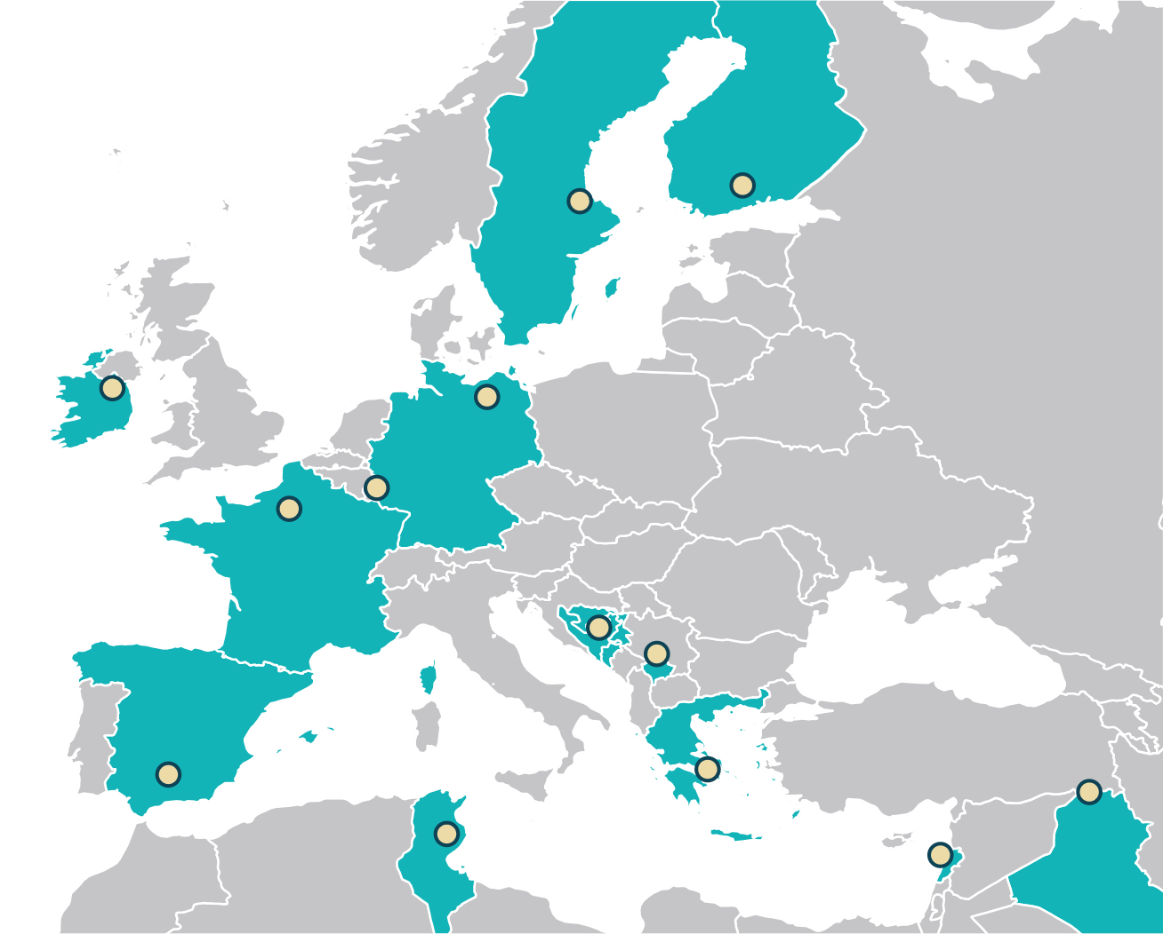

**Introduction to PAVE research in Kosovo**



The research in Kosovo, led by the Kosovar Centre for Security Studies (KCSS), was conducted in 2021 and included 32 interviews and four focus group discussions, carried out in three field sites: the Municipality of **Mitrovica South**,[1] the Municipality of **Mitrovica North**[2] and the Municipality of **Podujeva**.[3] These field sites were selected because they share a similar socio-economic context, but were differently affected by radicalisation (KCSS 2020, KIPRED 2018). Whereas the Mitrovica municipalities have seen a higher exposure to ethno-political and religious radicalisation, the municipality of Podujeva has shown a higher degree of resilience, particularly to religious radicalisation. Accordingly, the selected field sites provided important information for comparative analysis of why some areas in Kosovo were more vulnerable to radicalisation compared to others. In addition to this, the Mitrovica area is divided along ethnic lines, between Kosovar Albanians (predominantly Muslim) and Kosovar Serbs (predominantly Orthodox Christian).[4] The division of the city has been a constant source of ethnic tension, which has fuelled both religious and ethno-political radicalisation. The area of Mitrovica is hence an important case study of cumulative extremism and how different identities are utilised in the process of othering between the Albanian and Serbian communities, or how ethno-political extremism increases the risk of religious extremism, and the other way around. In Mitrovica, radicalisation based on religious identities (i.e. Muslim and Christian Orthodox) increases the risk of extremism based on ethnic identities (Albanian versus Serb). In other words, religious radicals seek to conflate the two identities in order to strengthen their narratives of othering by trying to define the indicators that constitute a “good” Albanian or Serbian.

The research showed that despite significant progress, inter-ethnic relations in Kosovo remain fragile, especially among the Albanians and Serbs. Due to the lack of a comprehensive normalisation of relations between Kosovo and Serbia in the framework of the EU-facilitated Dialogue, the **complex inter-ethnic relations** in Kosovo are ripe for instrumentalisation by radical groups, especially from the far right, to incite tensions and violence. Heightened ethnic tensions often strengthen religious extremism and feed into each other (Svensson and Nillson 2022). One of the most relevant factors that seems to explain the community vulnerability to ethno-political radicalisation in Kosovo is the **lack of a successful process of dealing with the past**, which has led to competing narratives between the two communities (Kosovo Albanians and Kosovo Serbs) about what happened during the 1990s, and a failure to recognise the victims of the war. This is often manifested through denial of well-established facts about horrific war crimes that were committed during the conflict. There is a strong sense, especially among the youth, that the transitional justice mechanisms, both local and international, have failed to bring the war criminals to justice (Hoxha et al. 2021).

On the other hand, the PAVE research has shown that, in areas like the municipality of Podujeva, community resilience to radicalisation was shaped by different socio-political factors, including a high level of **cooperation** and communication between religious institutions and local leaders with the public institutions. In addition to this, **religious leaders’ personal values** or norms were important to foster community resilience. For instance, in the municipality of Podujeva, some religious leaders promoted messages of respect and support towards state institutions and the country’s constitution. In this context, **tradition** and family norms also seem to play a role in fostering community resilience to religious radicalisation, which is to say that communities that attached more importance to traditional norms and were more conservative towards their ethnic identity rejected any efforts that would change the status quo. **Active civil society** is also an important factor of community resilience, understood as a community’s awareness of a phenomenon and its collective action to oppose its influence. In other words, communities with a higher degree of youth and civil society activism and presence of non-government organisations that work on governance and democracy issues are more resilient to ethno-political and religious radicalisation. In the case of Kosovo, a significant source of resilience to radicalisation has been the communities’ strong **belief in a future for their country in the European Union** (EU), which has provided an important anchor and a common denominator for all communities in Kosovo, something that brought all of them together, despite the differences, as a goal to aspire towards. However, as the EU’s enlargement policy grows increasingly uncertain, this may further weaken social cohesion in Kosovo.

1. **Recommendations for the government**

* The Ministry of Internal Affairs or, more specifically, the Department for Public Safety should develop its **analytical and research capacities with respect to online (de)radicalisation**, in order to enable the public institutions to gain a better understanding of how the online sphere impacts radicalisation and deradicalisation efforts. Additionally, capacities to prevent online radicalisation and disinformation efforts should be strengthened in the Ministry of Internal Affairs; this would include mechanisms of monitoring and rapid response to fake news that is aimed at radicalising the population. This is particularly relevant in regard to inter-ethnic relations, as isolated incidents are sometimes exploited to promote hate speech or messages that seek to mobilise a public reaction.
* The government of Kosovo should decentralise the programmes, policies and mechanisms aimed at Preventing and Countering Violent Extremism (P/CVE), by **delegating more authority and resources to municipal institutions**. The municipality of Mitrovica South is the only local institution with a dedicated programme to counter violent extremism, which was approved by the Municipal Assembly in 2019.[5]
* The government should recognise the emerging threats to societal peace in the country from **ethno-political radicalisation and the far right** in Kosovo, which are fostered *inter alia* by competing narratives about the war crimes that happened during the conflict in the 1990s and by bilateral disputes between Kosovo and Serbia. Policies that aim to promote reconciliation and dealing with the past are important measures to prevent far-right extremism in the country. In this context, it is of particular relevance for the government to implement an **outreach and dialogue campaign with the Kosovo Serb community**.
* Programmes that support the development of **critical thinking among secondary school pupils**, e.g. through active debate clubs, are important tools to prevent overall radicalisation campaigns aimed at the youth. The Ministry for Youth, Culture and Sports should consider partnering with civil society organisations specialised in developing debating skills among the youth in order to promote debate and encourage the establishment of debating clubs in secondary schools.
* **Media literacy** in general and online media literacy in particular are very important to foster community resilience to radicalisation. Accordingly, the government should increase support for media literacy subjects for secondary schools and, through partnerships with civil society, organise online media literacy seminars in different communities.
* Fake news and disinformation are major factors contributing to community vulnerability to radicalisation. The government should improve capacities to **counter fake news and disinformation efforts** through cooperation with existing mechanisms such as the Independent Media Commission (IMC), which is responsible for establishing and implementing policy and regulating the broadcasting rights, obligations and responsibilities of individuals and entities who provide audio and audiovisual media services.

1. **Recommendations for the international community**

* The European integration process is central to keeping the countries of the region committed to fostering the liberal-democratic normative framework and regional cooperation. The EU’s credibility in Kosovo has suffered in recent years as a result of the failure to deliver on visa liberalisation for Kosovars, who remain the only citizens in the Western Balkans to still require a visa to enter the Schengen area. There is a growing public sentiment in Kosovo that delays in visa liberalisation are connected with prejudices among some EU member states towards Kosovo, and this sentiment is exploited and forms a central part of the religious and far-right radicalisation narratives. The international community and particularly the EU should work to **energise the European integration process for the Western Balkans**, and the EU Office in Kosovo should more actively promote the EU-funded projects in the country.
* The international community in Kosovo (the EU embassies, the EU Office, international development organisations such as USAID and UNDP, etc.) should refrain from actions and discourse that foster the perception that violent extremism and radicalisation are inherently religious in nature. The international community should acknowledge other forms of radicalisation and prioritise local support for deradicalisation through a focus on community leaders. One way to do this is by **changing the narrative** in the official statements and speeches on P/CVE and by shifting funding priorities in order to focus on building community resilience against disinformation and any form of radicalisation. It is also important to acknowledge the important role that the Islamic community in Kosovo has played in promoting religious tolerance and to recognise the individual work of Imams in this context. The European Commission can change the language in its annual country report for Kosovo when referring to violent extremism in order to recognise cumulative extremism and other forms of extremism while reducing the emphasis on religious extremism. In addition to this, there needs to be **increased financial support for research on the impact of far-right extremism** in the Western Balkans, especially in multi-ethnic countries such as Kosovo.
* There should be a stronger push for better government policies and communication between public institutions at the central government level, municipal authorities and civil society organisations in dealing with P/CVE. The international community can help by **pushing for more coordination and communication** between the government and non-government sectors, but also by participating in multi-stakeholder consultative meetings and forums on P/CVE, which would increase the credibility of such mechanisms or meetings. The international community can also help by recognising and giving credit to existing government initiatives or mechanisms that focus on communication and coordination on violent extremism issues.

1. **Recommendations for civil society**

* Government mechanisms on P/CVE, but also well-established NGOs in Kosovo that work on P/CVE issues, should **cooperate more actively with faith-based and community leaders** in deradicalisation campaigns. Among civil society organisations, there are emerging groups of NGOs that work on addressing the ideological aspects of the radicalisation process and have developed important tools to counter the use of religious doctrine to justify violent extremism (i.e. [FolTash](https://foltash.org/)).
* Religious communities and newly formed faith-based civil society organisations need to play a more active role in P/CVE, including in planning and implementing programmes, but also, very importantly, in shaping the public discourse on violent extremism. Meaningful engagement of faith-based leaders and religious practitioners is important to **counter inaccurate public perceptions of the work of civil society in P/CVE**.
* Civil society organisations in Kosovo can make significant contributions to the deradicalisation process and provide important services to returnees from the war zones in Syria and Iraq in the framework of **rehabilitation and reintegration programmes**; however, such services should be offered through partnerships with public institutions. Of particular relevance in this context are mental health care and psychosocial wellbeing, as public institutions often lack the capacities and resources to provide such support. NGOs should consider developing capacities in these areas and specialising in the delivery of these services by working in partnership with public institutions to develop and implement programmes that support mental health and psychosocial wellbeing.
* Civil society organisations should prioritise the development of capacities to effectively **monitor and counter fake news, disinformation and online radicalisation propaganda**. This should include developing research and monitoring capacities through training and twinning opportunities with think tanks from the EU member states, but also through technical assistance by developing software programmes that help track disinformation and fake news and creating a database. Think tanks in Kosovo should focus their research on debunking myths that seek to radicalise the public on the basis of ethnic and religious identities. New capacities should also lead to improved communication and interaction between Kosovar think tanks and social media platforms such as Twitter and Facebook, to counter fake news and disinformation campaigns.
* While research and monitoring are considered strengths of the civil society organisations in Kosovo, advocating and translating their research into public policies is more challenging. Accordingly, civil society should more actively promote **cooperation with the public sector** to ensure that their programmes are sustainable and lessons learned can be translated into public policies.

** References**

Erblin Hoxha, Ardi Shatri, Vigan Sejdiu and Fatbardhë Kiqina (2021). Kosovar Youth Perceptions of Relations with Serbia, Transitional Justice, Reconciliation and Dealing with the Past. Debate Center. <https://debatecenter.org/wp-content/uploads/2021/04/Kosovar-youth-perceptions-of-relations-with-Serbia-transitional-justice-reconciliation-and.pdf>

Ramadan Ilazi, Ardit Orana, Teuta Avdimetaj, Bledar Feta, Ana Krstinovska, Yorgos Christidis and Ioannis Armakolas (2022). Online and Offline (De)radicalisation in the Balkans. Working Paper 5. PAVE Project Publications. www.pave-project.eu/publications/PAVE_870769_D5.1_publication_layout.pdf

Kosovar Centre for Security Studies (KCSS) (2020). Kosova Resilience Index – Violent Extremism in Kosova: What Community Resilience Can Teach Us? <https://qkss.org/images/uploads/files/Resilient_paper_eng_641966.pdf>

Samet Dalipi and Shala Krenar (2016). The Role of Decentralization on Security Improvement and Peace-building in Kosovo”. Prishtina: Friedrich-Ebert-Stiftung. <https://library.fes.de/pdf-files/bueros/kosovo/13856.pdf>

Kosovar Institute for Policy Research and Development (KIPRED) (2018). Prevention of Radicalization and Violent Extremism: Lessons from the Positive Cases of Podujevo and Suhareka Municipalities. [www.kipred.org/repository/docs/Prevention_of_Radicalism_and_Violent_Extremism_-_Positive_Cases_-_Podujevo_and_Suhareka_(1)_(2)_851758.pdf](http://www.kipred.org/repository/docs/Prevention_of_Radicalism_and_Violent_Extremism_-_Positive_Cases_-_Podujevo_and_Suhareka_(1)_(2)_851758.pdf)

Municipality of Mitrovica South (2019). Municipal Plan for Prevention of Violent Extremism among Youth. <https://kk.rks-gov.net/mitroviceejugut/news/komuna-e-mitrovices-pritet-te-behet-me-planin-komunal-per-parandalimin-e-ekstremizmit-te-dhunshem-ne-mesin-e-te-rinjve-2020-2022/>

Isak Svensson and Desirée Nilsson (2022). Cumulative Extremisms in the Balkans and MENA Region. Synthesis Report. PAVE Project Publications. <https://www.pave-project.eu/publications/PAVE_870769_D3.3_publication_layout.pdf>

Sead Turčalo, Jelena Brkić-Šmigoc, Mirza Smajić, Veldin Kadić, Muamer Hirkić, Maja Halilovic Pastuovic, Goran Tepšić, Nemanja Džuverović and Gillian Wylie (2022). Cumulative Extremisms in the Balkans. Working Paper 1. PAVE Project Publications. <https://www.pave-project.eu/publications/PAVE_870769_D3.1_publication_layout.pdf>

1. See the OSCE Kosovo Profile of Mitrovicë/Mitrovica South: [www.osce.org/mission-in-kosovo/122118](http://www.osce.org/mission-in-kosovo/122118)
2. See the OSCE Kosovo Profile of Mitrovica/Mitrovicë North: [www.osce.org/mission-in-kosovo/122119](http://www.osce.org/mission-in-kosovo/122119)
3. See the OSCE Kosovo Profile of Podujevë/Podujevo: [www.osce.org/kosovo/13126](http://www.osce.org/kosovo/13126)
4. The municipalities of Mitrovica South and North used to be a single administrative unit, but following the 1999 war in Kosovo, the area was divided into two parts to prevent violence between the Albanian and Serbian communities. The division of the city runs across the river Ibar, the north part of the city being inhabited predominantly by Serbs. The bridge over the Ibar river in Mitrovica has become a symbol of division and ethnic tensions in Kosovo since 1999 and has come to characterise the difficulties of fostering a multi-ethnic society in post-conflict settings. In 2007, the Special Envoy of the United Nations (UN) for the Future Status Process for Kosovo, Martti Ahtisaari, submitted to the UN Security Council his Comprehensive Proposal for the Kosovo Status Settlement, commonly referred to as the Ahtisaari Plan, which included an obligation for Kosovo to implement a decentralisation process and create new municipalities in Serbian-majority areas in Kosovo in order to facilitate the integration of the Serbian community in Kosovo.
5. See, for instance, the news article from the official website of Mitrovica South municipality from 2019 announcing the completion of the drafting of the Municipal Plan for Prevention of Violent Extremism among Youth: <https://kk.rks-gov.net/mitroviceejugut/news/komuna-e-mitrovices-pritet-te-behet-me-planin-komunal-per-parandalimin-e-ekstremizmit-te-dhunshem-ne-mesin-e-te-rinjve-2020-2022/>